CSC 241 HW1

**Question 1 (22 Points)**: Consider the code below, which calculates the sum of all numbers from 1 to n. Here, n is a positive integer. Write the recursive version of this code. Test your code for these n values: 25, 50, 67, 100.

**Question 2 (25 Points)**: In this problem, you need to create a singly linked list containing 𝑁 integers (𝑁 ≥ 10) with at least 3 or more duplicate items. The head and tail must have to be a duplicate item and insert more duplicate items at other random position (see the sample inputs below for clarity, red colored items are duplicate).

**Question 3 (14 Points)**: Consider the following definition for a function SplitNum(int N).

𝑆𝑝𝑙𝑖𝑡𝑁𝑢𝑚(1) = 1

𝑆𝑝𝑙𝑖𝑡𝑁𝑢𝑚(𝑛) = 𝑆𝑝𝑙𝑖𝑡𝑁𝑢𝑚((𝑛 + 1)/2) + 𝑆𝑝𝑙𝑖𝑡𝑁𝑢𝑚(𝑛/2)

1. According to the definition, what is the value of SplitNum(9)? Show intermediate steps while calculating the final value.  
   Text

   Description automatically generated
2. We wrote the following wrong recursive pseudocode to implement 𝑆𝑝𝑙𝑖𝑡𝑁𝑢𝑚(𝑛). Modify this code snippet so that it works properly.  
   **The code for rewriting the program is in screenshot above.**

**Question 4 (15 Points):** Consider the following code snippets and answer the following questions.

• What will be the output if we call “DigitSum(81406)”?

**19 is the output of DigitSum(81406).**

• Write the recursive version of “DigitSum(num)”. Unlike Question 1 and 2, it does not have to be fully functional java code. A logic with proper/adequate comments will be sufficient.

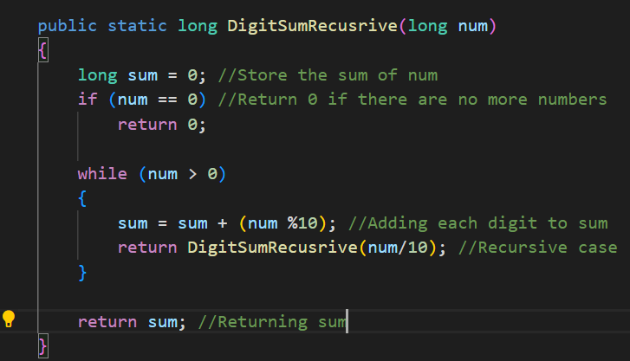

**Question 5 (14 Points**): Assume a classroom is divided into multiple columns, each containing several students. You pick a random student and ask him/her two simple questions:

• How many students are directly behind you in your column?

• How many students are directly in front of you in your column?

**Question 6 (10 Points):** Consider the following questions and determine whether they are True or False.

1. In a linked list, the first node never refers to NULL. **False**
2. II. A linked list uses dynamic type of memory allocation. **True**
3. III. Accessing the 5th element Vs accessing the 500th element takes same amount of time in an array. **True**
4. IV. Accessing the 5th element Vs accessing the 500th element takes same amount of time in a linked list. **False**
5. V. Static Memory Allocation is better than dynamic memory allocation when we want to utilize memory efficiently. **False**